
TECHNICAL NOTE
LSU-05 NG

THIS TECHNICAL DOCUMENT MANAGED AND CONTROLLED BY:

ENGINEERING DATA MANAGEMENT FUNCTION

Document Number: | UAV Model:  LSU-05 NG
Title:
LOAD ANALYSIS

Prepared By | : |  | Signature | :
Prepared By | : |  | Name | :
Prepared By | : |  | Position | :
Checked By | : |  | Signature | :
Checked By | : |  | Name | :
Checked By | : |  | Position | :
Approved By | : |  | Signature | :
Approved By | : |  | Name | :
Approved By | : |  | Position | :

Additional page for signature, see next page.

Revision | : | A
Date | : |  |  | Page | : |  |  |  | 11 of 23

DISTRIBUTION LIST

Copy Number | Institution / Organization / Agency

REVISION PAGE

Revision Index | Description | Revision Date |  | Approval
 |  |  |  | Prepared
 |  |  |  | Checked
 |  |  |  | Approved

TABLE OF CONTENTS
Page

DISTRIBUTION LIST 2
REVISION PAGE 3
TABLE OF CONTENTS 4
1 INTRODUCTION 6
1.1. Objective 6
1.2. Scope 6
1.3. Configuration Summary 6
1.4. Applicable Requirements 7
1.5. References 7
2 FLIGHT CONDITIONS 8
2.1. Reference Axes 8
2.2. Sign Conventions 8
2.3. Input Data Analysis 8
2.3.1 Geometry 8
2.3.2 Mass Configuration 8
2.4. Flight Envelop 9
2.4.1 Limit Maneuvering Load Factors 9
2.4.2 Design Airspeeds 9
2.4.3 Limit Gust Load Factors 9
2.5. Flight Load Cases 10
2.5.1 Nomenclature 10
2.5.2 Flight Loads Description 12
2.5.3 Flight Load Analysis Results 13
3 GROUND LOAD CONDITIONS 14
3.1. Reference Axes and Sign Conventions 14
3.1.1. Reference Axes 14
3.1.2. Sign Conventions 14
3.2. Input Data Analysis 14
3.2.1. Geometry 14
3.2.2. Mass Configuration 15
3.3. Sinking Speed 15
3.4. Ground Reaction Factor 15
3.5. Nomenclature 15
4 FUSELAGE LOAD ANALYSIS 18
4.1. Reference Axes and Sign Conventions 18
4.1.1 Reference Axes 18
4.1.2 Sign Conventions 18
4.2. Input Data Analysis 18
4.3. Fuselage Load Analysis Results 20
5 WING LOAD ANALYSIS 21
5.1. Reference Axes and Sign Conventions 21
5.1.1 Reference Axes 21
5.1.2 Sign Conventions 21
5.2. Input Data Analysis 22
5.2.1 Wing Structural Load Reference 22
5.2.2 Wing Mass Distribution 22
5.2.3 Wing Aerodynamic Pressure Distribution 23
5.2.4 Wing Finite Element Model 23
5.3. Wing Load Analysis Results 23

Jika Ada

List of Table

List of Figure

List of Appendix

List of Attachment

INTRODUCTION

Objective
This document presents static load analysis of Pesawat Terbang Tanpa Awak (PTTA) LSU-05 NG. ( Wajib)

Scope
The document covers load analysis of fuselage, wing, horizontal tail, vertical tail and engine mount structures in flight and ground cases. Section 2 presents the flight load conditions and Section 3 presents the ground load conditions. The load results are presented in term of sectional loads such as shear force, bending moment and torsion and pressure distribution. (Wajib)

Configuration Summary /Definition and Abbreviation (Jika Ada)
The PTTA LSU-05 NG is an Unmanned Aerial Vehicle which is developed by LAPAN Design Organization.

PTTA LSU-05 NG is an Unmanned Aerial Vehicle (UAV) with double boom inverted V-tail. PTTA LSU-05 NG is a single engine aircraft with semi-monocoque composite fuselage, dual tail boom and inverted V-tail configuration. The aircraft has straight wing with high wing configuration without landing gear.

The aircraft is launched using launcher and lands using a parachute. This aircraft also equipped with floating device to prevent the aircraft sinking when the aircraft lands on the water.

The following figures show the three-view drawing of The PTTA LSU-05 NG.

PTTA LSU-05 NG Three Vie Drawing
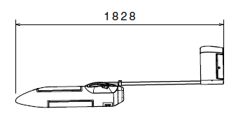
Figure 1.1 Side View PTTA LSU-05 NG
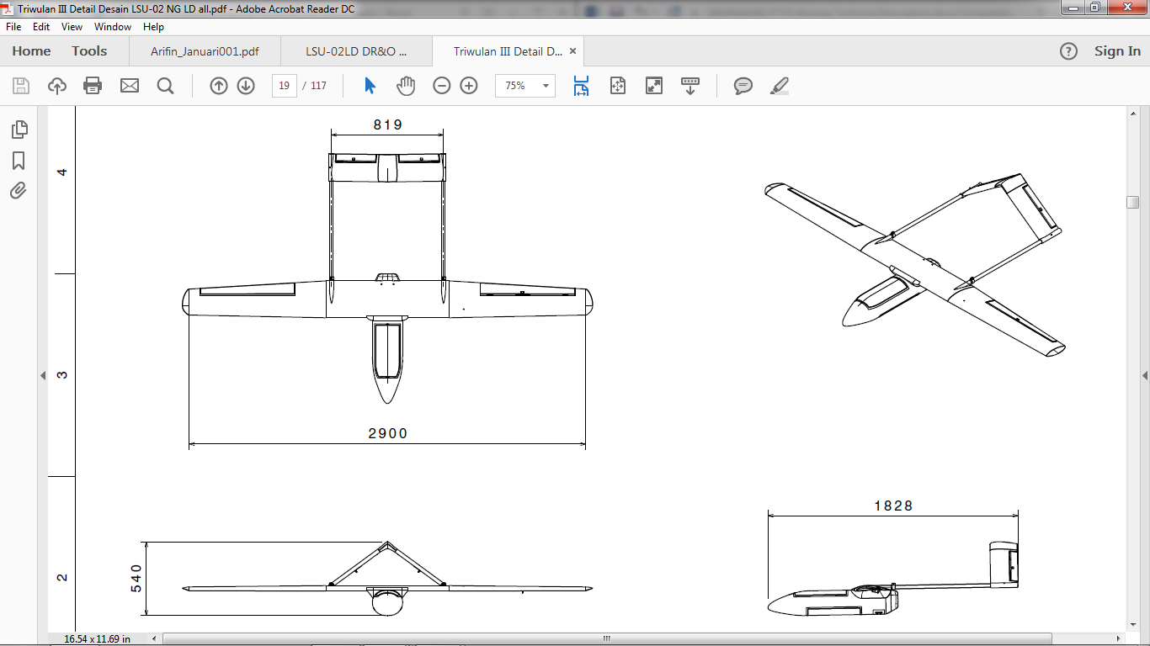
Figure 1.2 Top View PTTA LSU-05 NG
Figure 1.3 Front View PTTA LSU-05 NG

Applicable Requirements (WAJIB)

The PTTA LSU-05 NG is designed for certification compliance with the applicable requirements of CASR Part 23, Normal Category Airplane as stated in PTTA LSU-05 NG Certification Plan Document.

Safety Anlaysis : tambahin Description
Test Plan : tambahin Configuration
Test Report : tambahin Conclution

References (WAJIB)

- PTTA LSU-05 NG Technical Description.
- Load Data Package PTTA LSU-05 NG.
- PTTA LSU-05 NG Weight and Balance Control and Loading Data.
- PTTA LSU-05 NG Stress and Strength Analysis.
- FAR Part 23, Airworthiness Standard Normal Category Airplane.
- PTTA LSU-05 NG Compliance Check List.
- PTTA LSU-05 NG Three View Drawing.
- PTTA LSU-05 NG Technical Description.

MAIN DOCUMENT (CONTOH : FLIGHT CONDITIONS)
Techincal Description : System Description
Structure Analysis : 1. Result / Conclution 2. Structural analysis
System Analysis : 1. Result / Conclution 2. Design analysis
Safety Anlaysis : 1. Safety Objective 2. Conclution 3. Analysis and test summary 4. System limitation
Test Plan : 1. test Objective 2. Test condition 3. Test Procedure 4. Test Instrumentation
Test Report : 1. Test Condition 2. Analysis of test result

Appendix

oo OO oo

